Mock-up prototype assets for a company website.

**Pick one of the following organizations:**

Automotive manufacturing factory

Police, fire or ambulance service

Privately owned family business (local)

Micro-brewery

Non-profit fundraiser

**Situation**

The organization is having an event.

**Options** - open house, hiring fair, anniversary celebrations, relaunch (product or company), holiday party, supplier appreciation, retirement, milestone achievement, team building, seminar, conference, company barbeque, etc…

Pick **ONE** that you think is good.

You will need to include basic but important details (what, when, where) and a few other notes or announcements (activities, rsvp, etc…) as you feel is needed.

**Deliverable #1 - Asset: 1 custom event composite image -** raster **PSD**

***Note:*** *The image must contain event details including text, minimum two images, general design principles (as discussed in PROG over the last 7 weeks), be eye-catching (attract attention), and properly sized (see other tasks below before creating)*

*Save as a PSD (so I can see your work) and as a JPG (to be used below)*

*This is to be 72 ppi resolution and will be the background for the banner ad (Deliverable #3)*

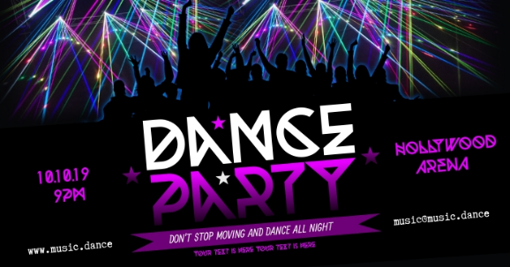 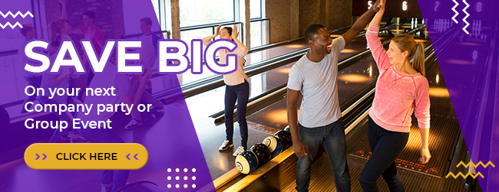

*Note the layered images in these examples. Do not copy these but feel free to be creative.*

**Deliverable #2 - Asset: Event logo for company event -** vector **AI**

*Note: this is a simple logo for the event. You* ***may*** *choose to include the company/organization logo, but it must have the name of the event. Add colour as you feel is needed. Obviously, font choice is extremely important as it should be easy to read and suit the type of event. More on this during the class demonstration.*

*You must include this in your Photoshop image (see above).*

*Make the logo about 60% of the page size and centre it on the artboard.*

*THIS IS NOT A LOGO FOR THE COMPANY - it is for the event.*

***Examples (do not use these):***

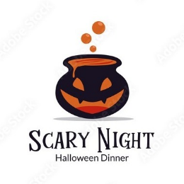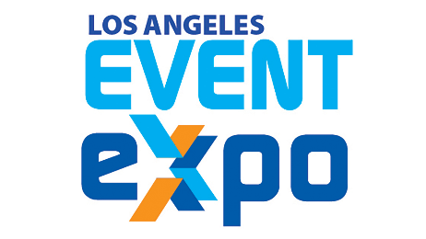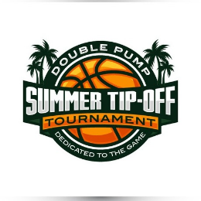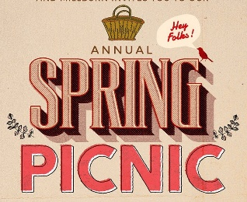

**Deliverable #3 - Asset: One banner concept -** onone **XD** artboard

*Use the pre-set social media banner sizes in XD that would work for all social media pages (research the sizes available to find one that works). Sized for Facebook event page, Twitter, and Instagram. If you want to create a different size for each, that is up to you, but* ***I am only looking for one****.*

*You want the image you made in PSD and the event logo represented here. You can add or change as needed.*

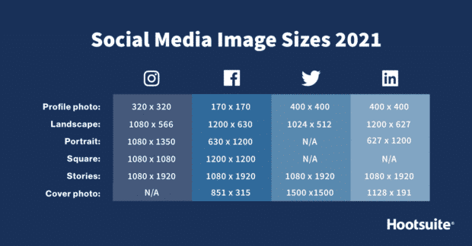

# **Submission Instructions**

Use [this Assignments folder](https://conestoga.desire2learn.com/d2l/lms/dropbox/user/folder_submit_files.d2l?db=504750&grpid=0&isprv=0&bp=0&ou=488879) to submit your completed task.

I am looking for 4 total files…

1. PSD of Deliverable #1
2. JPG of Deliverable #1
3. AI of Deliverable #2
4. XD of Deliverable #3

*If you use any other files or formats to complete your work,* ***DO NOT SUBMIT THEM****.*

Submit the files with proper names (always include your last name) so I know what they are just by reading the name. You can submit individually or in a zipped folder. **This is due before class in Week 10 - Tuesday November 9 at 11:59 PM.**